Department of Civil & Environmental Engineering Graduate Handbook  2022-2023 | Contains departmental policies for Graduate Degrees in: Civil Engineering, and Nuclear Engineering.

Safety and Wellness
Your safety is our top priority. In an emergency, dial 911 or seek a nearby emergency phone (throughout campus). Report any crimes or suspicious people to 801-585-COPS; this number will get you to a dispatch officer at the University of Utah Department of Public Safety (DPS; dps.utah.edu). If at any time, you would like to be escorted by a security officer to or from areas on campus, DPS will help — just give a call.
The University of Utah seeks to provide a safe and healthy experience for students, employees, and others who make use of campus facilities. In support fo this goal, the University has established confidential resources and support services to assist students who may have been affected by harassment, abusive relationships, or sexual misconduct. A detailed listing of University Resources for campus safety can be found at https://registrar.utah.edu/handbook/campussafety.php
Your well-being is key to your personal safety. If you are in crisis, call 801-587-3000; help is close. The university has additional excellent resources to promote emotional and physical wellness, including the Counseling Center (https://counselingcenter.utah.edu), the Wellness Center (https://wellness.utah.edu), and the Women’s Resource Center (https://womenscenter.utah.edu). Counselors and advocates in these centers can help guide you to other resources to address a range of issues, including substance abuse and addiction.
Emergency Resources:
University Police  dps.utah.edu  911 or 801.585.2677 | Crisis Line (24/7):  801.587.3000  For crisis intervention, emotional support, and mental health needs |  | SafeUT. Online Chat.  833.372.3388  Download the free app. |  | Suicide & Crisis Lifeline:  988 or 1.800.273.8255  988 will route callers to the National Suicide Prevention Lifeline.
Additional Resources:
University Counseling Center  Mon – Fri 8 a.m. - 5 p.m. 801.581.6826 |  | The Dean of Students.  Mon – Fri 8 a.m. - 5 p.m.  801.581.7066 deanofstudents@utah.edu  Drop-In Appointment | |  | Student Health Center  Listing of Hours.  801.581.6431
Center for Student Wellness. Victim- Survivor Advocacy.
Mon – Fri 8 a.m. - 5 p.m. Request an Appointment.
801. 581.7776 | advocate@sa.utah.edu
Services for those who have experienced interpersonal violence (i.e. domestic or dating violence, sexual assault or rape, sexual harassment, stalking, etc.)

Table of Contents
Department of Civil & Environmental Engineering 3
Vision 4
Mission 4
Welcome 3
Safety and Wellness 1
Departmental Contacts 5
A Reminder of Student Responsibility. 5
Admissions 6
Remedial Coursework for Graduate Study in Civil Engineering 7
Remedial Coursework for Graduate study in Nuclear Engineering 8
Non-Matriculated Students 8
Degrees Offered 8
by Discipline 8
by Level of Study 8
Masters: 9
Master’s Level Learning Outcomes [CIVIL} 9
Master’s Level Learning Outcomes [NUCLEAR] 9
Credit Hour Requirements for Degree Completion. 10
Supervisory Committee Formation: 11
Examinations: 13
Doctoral Study: 14
Doctoral- Level Learning Outcomes [CIVIL] 14
Doctoral- Level Learning Outcomes [NUCLEAR] 14
Degree requirements, as defined by the Graduate School: 14
I. Direct Admit PhD (BS to PhD) 15
II. Traditional PhD (BS to MS to PhD) 15
Supervisory Committee Formation: 15
Examinations: 15
Appendices 24
1. What happens in the event the supervisory committee chair leaves the University of Utah? 24
2. Pregnant Graduate Assistant* Accommodation Policy 24
3. Time to Completion 25
4. International Students 25
5. FERPA & Umail 25
6. Grades & Probation Policy 26
7. Registration 26
8. Leave of Absence and Vacation Semesters 26
9. Independent Study 26
10. Academic Calendar 27
11. Coursework Requirements by Discipline 29
Water & Environmental 29
Transportation & Materials 31
Structures & Geotechnical 32
Nuclear 34

Welcome
Thank you for reviewing the Department’s Graduate Handbook. This document has been thoughtfully crafted to present information and policies applicable to graduate students in the Department of Civil and Environmental Engineering. Students should review the handbook prior to the start of each academic year to encourage the continued progress towards degree completion.

Other resources:
• Students may also consult the Graduate Catalog concerning University policy available at: gradschool.utah.edu/graduate-catalog
• Students should also review, Policy 6-400 the Code of Students Rights and Responsibilities, found at: regulations.utah.edu

Department of Civil & Environmental Engineering
The Department of Civil and Environmental Engineering offers graduate study in the fields of: Construction Engineering (MS); Environmental Engineering (MS & PhD); Geotechnical Engineering (MS & PhD); Materials Engineering (MS & PhD); Nuclear Engineering (MS & PhD); Structural Engineering (MS & PhD); Transportation Engineering (MS & PhD); Water Resources Engineering (MS & PhD).
With diverse degrees and course offerings the department attracts students from a wide array of academic fields. This graduate handbook is intended to clarify expectations and processes for students in the department. Please note, students are responsible for knowing the expectations and policies contained within this document.

Vision
CVEEN education and research enables and advances safe, secure, and resilient civil infrastructure systems that address societal needs for sustaining modern standards of living. The department is a place where all students have the opportunity to be inspired by a challenging, stimulating, and supportive community and curriculum. Such intellectual inspiration is seen in the engagement of the civil infrastructure community of practice embracing excellence, ethics, and equality.

Mission
The mission of the Department of Civil & Environmental Engineering at the University of Utah is to advance the smartness, resiliency, and sustainability of civil infrastructure systems.
The Department’s education and research programs are grounded in scientific theories, yet modernized via an amalgam of systems engineering and advanced computing. The intellectual foundations in evolving and critical area address grand societal challenges for planning, designing, constructing and operating interdependent civil infrastructure systems, including building, infrastructure, environmental, energy, and health systems.
We strive to inspire and prepare students for high-impact careers in the engineering profession and in the broader societal context, and develop engineers with strategic skills in areas of emerging need, with the creativity to adapt and innovate in response to dynamic societal needs.

Departmental Contacts
Staff Member/ Role | Responsibilities with Graduate Students | Contact Info
Courtney Phillips;  Graduate Advisor | Admissions; new student orientation; responsible for knowing University/ College / Department policy; tuition benefit / subsidized health insurance contact. | Office: MCE 2008  801 581 6678
Tiffany Hortin;  Administrative Manger | Payroll; assigning student desks; reimbursements; manages the schedule for the department chair. | Office: MCE 2003  801 581 6192
Angel Ames;  Accountant | Department contact for travel; building access/ keys. | Office: MCE 2004  801 585 7710
Dr. Ramesh Goel; Director of Grad. Study | Chairs the Department Graduate Committee: responsible for reviewing student request for exception to policy. | Office: MCE 2064  801 581 6110
Dr. Michael Barber;  Department Chair | Schedule appointments through Tiffany. | Office MCE 2002

A Reminder of Student Responsibility.
Adapted from University Policy 6-400 (Available in full here.)
The mission of the University of Utah is to educate the individual and to discover, refine and disseminate knowledge. The University supports the intellectual, personal, social and ethical development of members of the University community. These goals can best be achieved in an open and supportive environment that encourages reasoned discourse, honesty, and respect for the rights of all individuals. Students at the University of Utah are encouraged to exercise personal responsibility and self-discipline and engage in the rigors of discovery and scholarship.
Students at the University of Utah are members of an academic community committed to basic and broadly shared ethical principles and concepts of civility. Integrity, autonomy, justice, respect and responsibility represent the basis for the rights and responsibilities that follow. Participation in the University of Utah community obligates each member to follow a code of civilized behavior.
The purposes of the Code of Student Rights and Responsibilities are to set forth the specific authority and responsibility of the University to maintain social discipline, to establish guidelines that facilitate a just and civil campus community, and to outline the educational process for determining student and student organization responsibility for alleged violations of University regulations. University policies have been designed to protect individuals and the campus community and create an environment conducive to achieving the academic mission of the institution.
The Department issues the reminder, that the degree is the student’s own and, if applicable, the immigration record is the student’s own. Departmental and University staff and faculty will provide input, advice and clarification to students, but ultimately any action, or in-action, is the student’s own.

Admissions
Standard Application Process
- Complete an Online Application through Slate (FutureU.Admission.Utah.edu)
- Pay the appropriate application fee
- Submit a personal statement
- Submit a resume or Curriculum Vitae
- Provide contact information for three references
- Submit unofficial transcripts showing a completed bachelor’s degree from a regionally accredited college or university, with a minimum of 3.00 or higher GPA on a 4.0 scale.
- Request submission of Graduate Records Examination (GRE) taken within the last five years. A minimum combined score of 300 on quantitative and verbal sections are required for review, for this degree.

A NOTE REGARDING THE GRE:
Students applying to the non-thesis coursework only degree option, are not required to submit GRE scores if they have a US accredited degree and a GPA of 3.20 or higher.
TRADITIONAL PHD ADMISSION [CIVIL]:
Follow the standard application process above, no criteria modifications for this degree.
DIRECT ADMIT PHD [CIVIL]:
Follow the standard application process above, criteria modifications for this degree listed below:
- A minimum GPA of 3.50 on a 4.0 scale.
- A minimum quantitative score of 155 and minimum combined score of 300 on quantitative and verbal sections are required for review, for this degree.

Remedial Coursework for Graduate Study in Civil Engineering
Students who hold degrees in other academic disciplines may be required to complete remedial coursework prior to the start of the graduate degree.
All Students Must Complete:
Mathematics
MATH 2250 | Ordinary Differential Equations (and any prerequisite courses)
 | A Statistics Course
Sciences
PHYS 2210 | Physics for Scientists and Engineers
CHEM 1210 | General Chemistry 1
Basic Engineering
CVEEN 2010 | Statics
CVEEN 2140 | Strength of Materials
CVEEN 3410/ 3415* | Hydraulics / Hydraulics Lab
*CVEEN 3415 may be waived by supervisory committee if the student has successfully completed three or more labs in the prior degree.

Additional Requirements by Civil Engineering Graduate Emphasis:
Environmental/ Water Resources
CVEEN 3610 | Introduction to Environmental Engineering
Materials
CVEEN 3510 | Civil Engineering Materials
Structures/ Geotechnical
CVEEN 3210 | Structural Load and Analysis
CVEEN 3310/ 3315 | Geotechnical Engineering / Geotechnical Engineering Lab
CVEEN 4221 | Concrete 1
CVEEN 4222 | Steel 1
Transportation
CVEEN 3520 | Transportation Engineering
Additional coursework may be required by the supervisory committee. This is dependent upon the graduate academic emphasis and the prior degree awarded.

- Students who have an undergraduate degree in a field that is not Civil Engineering and are completing a Master’s program must complete the courses listed above- along with courses listed for their specific academic area of study in the second table. This includes those students who began studies as a PhD student, and have chosen to “Master-Out”. These students also must have successfully complete and pass the classes listed above. Students may also be formally excused from a particular course(s) if reviewed and approved by the faculty in that particular area.
- Students concluding their studies with a Doctoral degree from the Department of Civil and Environmental Engineering at the U of U only need to take remedial coursework as defined by the supervisory committee.
- These Departmental requirements recognize the difference in the work that is done by a Master’s-level engineer, and a doctoral-level engineer. It is for this reason that the remedial coursework differs by degree-level.

Remedial Coursework for Graduate study in Nuclear Engineering
Nuclear Engineering is a unique academic field that attracts students with a wide variety of academic backgrounds. For this reason, the only requirement for students applying for Graduate Study in Nuclear Engineering is three semesters of Calculus. Students applying to the the nuclear engineering program commonly have an undergraduate major in one of the following areas: mathematics, physics, computer science, chemistry, biology, or in a related science field.

Non-Matriculated Students
Students who must complete coursework prior to application to the graduate program should apply to University of Utah as a non-degree seeking student. Once a student is accepted to the University as a non-degree seeking student, they should work closely with the Graduate Advisor to learn about any additional steps needed to enroll (i.e. permission codes). Coursework completed as a non-matriculated student may count towards a student’s graduate program at the discretion of the student’s supervisory committee. Coursework completed as a non-matriculated student must receive a final grade of ‘B’ or better to apply towards a graduate degree. A maximum of nine non-matriculated credit hours may be applied to a graduate degree. International students on visas are not eligible for non-matriculated status.

Degrees Offered
by Discipline | by Level of Study
Civil Engineering  Master of Science in Civil & Environmental Eng.  Thesis  Non-Thesis (coursework only)  Doctor of Philosophy (PhD)  Direct Admit: Bachelor to PhD  Traditional: Masters to PhD  Utah Nuclear Engineering Program (UNEP)  Master of Science in Nuclear Engineering  Non-Thesis (coursework only)  Doctor of Philosophy  Direct Admit: Bachelor to PhD  Traditional: Masters to PhD | Master of Science  Non-Thesis (coursework only):  Civil & Environmental Engineering  Nuclear Engineering  Thesis:  Civil & Environmental Eng.  Doctor of Philosophy  Civil & Environmental Engineering  Nuclear Engineering

Masters:

Master’s Level Learning Outcomes [CIVIL}
- Competence within a well-defined core area of civil and environmental engineering at a level that clearly exceeds undergraduate expectations.
- Effective oral and written technical communication skills.
- Understanding of their selected area of research in one of the core areas of civil and environmental engineering at a level that clearly exceeds undergraduate expectations.
- Ability to conduct supervised research and to make personal contributions towards the solution of posed problems.
- Successful defense of an MS thesis and ability to contribute to technical reports and peer-reviewed papers.

Master’s Level Learning Outcomes [NUCLEAR]
- Demonstration of strong grounding in the fundamentals of nuclear engineering, thorough knowledge of the primary literature, and an ability to synthesize and critically evaluate information pertinent to one or more nuclear engineering disciplines.
- Demonstration of the advanced knowledge and expertise in one or more areas of specialization within the nuclear engineering discipline.
- Ability to solve complex engineering problems using advanced scientific and computational and analytical approaches pertaining to nuclear engineering disciplines.
- Ability to use some of the experimental tools of interest to nuclear engineering disciplines; examples are: nuclear detectors, research reactors, or similar.
- Ability to plan, execute and effectively communicate scholarly activities that make original contribution to the existing knowledge in one or more areas of specializations within the nuclear engineering discipline.
- Ability to communicate effectively both in written and oral forms.
- Preparation for life-long learners of nuclear engineering disciplines.
- Preparation for professional service in nuclear engineering disciplines.
- Preparation for leadership positions in nuclear engineering sector.
- Preparation for teamwork in nuclear engineering sector.
- Preparation for independence and initiative thinking, and importance of responsibility in executing nuclear engineering jobs.
- Knowledge of ethical, safety, socio-economic, and environmental aspects pertaining to nuclear engineering.

Credit Hour Requirements for Degree Completion.
The Graduate School requires candidates for master’s degrees to devote a minimum of 30 credit hours to their graduate courses (i.e., courses numbered 6000 and above) and thesis. For thesis-based Master’s degrees, a minimum of six credits of 6970 thesis research is required by The Graduate School. All coursework counted towards the degree must be approved by the student’s supervisory committee.
- The candidate is required to maintain a 3.0 or higher GPA in coursework listed on the Program of Study for the master’s degree.
- A grade below C- is not accepted by the University toward a graduate degree. Departments may have additional grade restrictions that must be maintained.
- At least 24 credit hours must be in resident study at the University of Utah.
Each academic group has identified core courses for students studying in the academic discipline. These listings are posted on the website, and in the appendix of this handbook.
Important Information. Relevant for All Graduate Degrees:
- Graduate credit hours are listed as 5000 and above.
- Students can include no more than 9 credit hours of graduate level non-matriculated coursework, taken within 3 years of course approval, with a final grade of B or better.
- Students can apply no more than 6 credit hours of graduate level coursework from another institution, with a final grade of B or better. This credit may not have counted towards the completion of a prior degree.

- MS Coursework Only (Non-Thesis)
- Civil
The Master’s Non-Thesis Degree is awarded for the completion of ten graduate-level courses (30 graduate credit hours) approved by the supervisory committee.

Credit requirements: A minimum of 30 credits of approved coursework
(15 Core and 15 Elective credits -Infrastructure students only)
TOTAL: A minimum of 30 graduate credit hours

In addition to coursework and credit requirements, non-thesis students must take and pass a comprehensive essay exam in their final semester of study. The exam is sent to non-thesis students in their final semester of study approximately two weeks into the academic semester, and must be returned to the Graduate Advisor by the date specified.

- Nuclear
Important Information:
- Up to 3 credits of independent research, taken as NUCL 6900 or 7900.
- Up to 12 credits of electives offered by other departments in engineering, science, and math-related disciplines that complement the student’s research. Elective courses may be taken in any science, engineering, technology discipline that supports your academic interests.

- Required Courses. | - Choose a minimum of FOUR additional NUCL electives from the list below.
NUCL 6030: Graduate Radiation Interactions (3 cr.)  NUCL 6050: Reactor Physics (3 cr.) | NUCL 5060: Reactor Operation and Regulatory Policy (3 cr.)  NUCL 6032: Graduate Radiochemistry (3 cr.)  NUCL 7110: Nuclear Environmental Engineering (3 cr.)  NUCL 7220: Analytical Nuclear Forensics (3 cr.)  NUCL 7000: Health Physics (3 cr.)  NUCL 7500: Nuclear Safeguards (3 cr.)  NUCL 7100: Nuclear Instrumentation (4 cr.)  MET E 6210: Nuclear Materials (3 cr.)  CVEEN 6120: Numerical Methods (3 cr.)
MS students must complete a minimum of 30 hours of graduate level coursework (5000 and above)
Credit requirements: A minimum of 30 credits of approved coursework

TOTAL: A minimum of 30 graduate credit hours

- MS Thesis- Civil Only.
The MS-Thesis is awarded for scholarly achievement of coursework and research and requires a successful defense of the thesis to complete the degree. Research is conducted with close supervision by the student’s faculty advisor and committee and results in a defense and publication of a thesis, making a contribution to the student’s interest area. The University of Utah allows, and the department encourages, students to use peer-reviewed journal articles to fulfill the thesis requirement. Master’s thesis typically consists of at least one journal quality article with additional explanatory material and appendices, as necessary. The student’s graduate committee is responsible for evaluating the research and publications; ultimately determining if the quality merits the degree sought, regardless of the number or status of the articles.

Beginning in Fall 2020 CVEEN 6555: Research and Seminar is required for all students completing a research degree. This can be counted towards the 24 credit hours of required coursework.
Credit requirements: A minimum of 24 credits of approved coursework
(15 Core and 9 Elective credits)
+ A minimum of 6 credits of research.
TOTAL: A minimum of 30 graduate credit hours

Supervisory Committee Formation:
What is a supervisory committee?
A supervisory committee guides and assists a student in working toward a graduate degree.

All appointed supervisory committee members are voting members of the supervisory committee. These individuals are productive scholars in the student’s major field and/or sub-fields.

Decisions concerning program requirements, examinations, and the thesis or dissertation are made by majority committee vote.

Student: the student’s responsibilities relating to their supervisory committee include:
- providing all members with a short summary of the program of study and research interests and an examination timeline;
- providing necessary General Examination materials to all committee members in a timely manner;
- providing necessary Final Examination materials to all committee members in a timely manner (this includes a draft of the entire dissertation to reading committee members);
- keeping the committee membership current and notifying the department’s Graduate Advisor of any committee changes in a timely manner
What are the responsibilities of the supervisory committee?
- For a non-thesis (coursework-only) student the committee holds two main responsibilities:
- Committee members ensure the coursework you select will provide for you the education needed to be a successful Master's-Level Engineer.
- Committee members will evaluate the non-technical comprehensive exam completed in the student's final semester of study.

- For a thesis student the supervisory committee is responsible for:
- assessing the student’s foundational knowledge, and formally noting deficiencies and any supplementary coursework for which no credit is granted;
- approving a course of study which will fulfill the general requirements of the degree;
- approving the thesis or dissertation subject,
- reading and approving the thesis or dissertation,
- administering and judging the final oral examination (thesis or dissertation defense).

In addition to the voting member responsibilities, the chair(s) of a committee must:
- be able and willing to assume principal responsibility for advising the student;
- have adequate time available for this work and be accessible to the student;
- attend both the General and Final Examinations and additional committee meetings, as necessary;
- sign the dissertation signature page acknowledging approval of the dissertation and completion of the degree
Who can serve on a supervisory committee?
- All University of Utah faculty members are eligible to serve as supervisory committee members.
- The faculty member must hold the terminal degree in the relevant field, and/or have demonstrated research and scholarly work in the field.
- Committee chairs must be selected from tenure-line faculty.
- Persons from outside the University of Utah may serve as committee members with approval of the Dean of The Graduate School.
- Immediate family members are not eligible to serve on a student’s supervisory committee.

The masters committee will be comprised of three members. The majority of these members must be faculty within the department, in the specified area of study.

MS Supervisory Committee:
Role | Requirements
- Chair | Tenure-line in home department.
- Member 2 | Tenure-line in home department.
- Member 3 | Another PhD
Nuclear Committees must have two Nuclear Core Faculty. As of August 2020 these faculty members are: Dr. Ed Cazalas, Dr. Luther McDonald, Dr. Tara Mastren, Dr. Glenn Sjoden.

Examinations:
Coursework-only degree: [Civil & Nuclear]
Students completing on of the MS non-thesis degrees will take an examination in their final semester of study. This examination is sent to students on the second Friday in the student’s last semester of study (also the University add/drop date). The materials the student can expect to receive at that time are an essay prompt to be completed by the student, and re-submitted to the Graduate Advisor on or before the date specified (typically 6-8 weeks later). This examination may call upon the student’s knowledge gained while completing graduate study at the University of Utah. Upon submission. This document will be provided to the student’s supervisory committee for evaluation and a vote of “Pass” or “No Pass”. The result of the examination is determined by majority committee vote. In the event “No Pass” is determined the student should expect to complete an oral examination from the supervisory committee.
Thesis-based degree: [Civil]
Master’s and doctoral candidates must submit a thesis or dissertation “...embodying the results of scientific or scholarly research or artistic creativity which gives evidence of originality and ability in independent investigation and is a contribution to knowledge or the creative arts.” Manuscripts “ . . . must show a mastery of the relevant literature and be represented in acceptable style. The style and format. . . are determined by departmental policy and registered with the thesis editor, who approves the style and format of individual [theses and] dissertations in accordance with departmental policy” (University Regulations Library 6-203-III-F).

Students should take the time to familiarize themselves with both the department, and University process concerning the Thesis including: submission deadlines, formatting requirements, current submission procedures. Further resources can be found at: gradschool.utah.edu/thesis

Doctoral Study:

Doctoral- Level Learning Outcomes [CIVIL]
- Complete independent research and advance the state of knowledge in the field. This is demonstrated by publishing a minimum of three peer-reviewed publications in archival journal, or by preparing a Ph.D. dissertation.
- Demonstrate strong grounding in the fundamentals, thorough knowledge of the primary literature, and an ability to design, communicate and execute a novel research plan.
- Demonstrate the significance of his/her contributions to the field, and professionally communicate the results.

Doctoral- Level Learning Outcomes [NUCLEAR]
See above master’s-level learning outcomes.

Degree requirements, as defined by the Graduate School:
The Doctor of Philosophy degree is awarded for high achievement in an advanced specialized field of study. It requires competence in independent research and an understanding of related subjects. The degree is not awarded simply for the fulfillment of residence requirements and the accumulation of credits. All requirements outlined for Master’s Degree completion must also be met.
- The candidate is required to maintain a 3.0 or higher GPA in course work listed on the Program of Study for the master’s degree.
- A grade below C- is not accepted by the University toward a graduate degree. Departments may have additional grade restrictions that must be maintained.
- At least one year (i.e., two consecutive semesters) of the doctoral program must be spent in full-time academic work at the University of Utah. A full load is nine credit hours.
- Beginning in Fall 2020 CVEEN 6555: Research and Seminar is required for all students completing a research degree. This can count towards the required coursework credits.
Residency Requirement, Additional Information:
When a student proceeds directly from a master’s degree to a Ph.D. degree with no break in the program of study (except for authorized leaves of absence), the residency requirement may be fulfilled at any time during the course of study.
Three hours of Thesis Research: Ph.D. (course number 7970) is also considered a full load after the residency requirement is fulfilled. Area specific requirements are outlined in the pre-approved courses linked

Credit Hour Requirement:

Direct Admit PhD (BS to PhD)
Minimum Credit Hour Requirements:
30 credit hours of coursework
+ 14 credit hours of dissertation research (CVEEN/ NUCL 7970)
44 credit hours

Traditional PhD (BS to MS to PhD)
Minimum Credit Hour Requirements:
18 credit hours of coursework
+ 14 credit hours of dissertation research (CVEEN/ NUCL 7970)
32 credit hours

Supervisory Committee Formation:
Please read the information provided in the Master’s Section regarding the supervisory committee expectations.
The doctoral committee will be comprised of five members. The majority of these members must be core faculty within the department, in the student’s area of study.
There are two rules that all PhD committees must follow:
- The committee chair and the majority of the committee must be tenure-line faculty in the student’s department.
- One member of the committee must be appointed from outside the student’s major department.
  - The outside member is normally from another University of Utah department.
  - The dean of The Graduate School may approve requests to appoint a committee member from outside the U of U where appropriate justification and supporting documentation is provided.

Role | Requirements
- Chair | Tenure-line in home department
- Member 2 | Tenure-line in home department
- Member 3 | Tenure-line in home department
- Member 4 | Typically another faculty within the department
- Member 5 | Outside member. Another PhD. (Outside department or U of U).
Nuclear Committees must have three Nuclear Core Faculty. As of August 2020 these faculty members are: Dr. Ed Cazalas, Dr. Luther McDonald, Dr. Tara Mastren, Dr. Glenn Sjoden.
Check a faculty member’s current rank at:
https://www.obia.utah.edu/data-dashboard/faculty-individual-information/

Examinations:

Preliminary Exam [Civil]
The purpose of the Preliminary Examination is to determine the student’s overall background and qualifications to continue in the graduate program towards a degree of Doctor of Philosophy. Students should submit a tentative CDP to their chairperson before the exam. Typically, the Preliminary Examination is taken no later than the second semester of a Ph.D. program to help identify the student’s understanding of basic principles and background, synthesis of knowledge, and general academic preparation (courses deemed necessary) to successfully pursue the Ph.D. program.

Scheduling: The Preliminary Examinations will be scheduled the Friday after fall break or spring break. New students enrolled in the Ph.D. program must take the Preliminary Examination no later than the end of their second semester at the University of Utah. Students who completed their M.S. at the University of Utah may be required by their Supervisory Committee to take the exam no later than the end of the first semester of the Ph.D.-level study. The Preliminary Exam must be completed at least one semester prior to the Research Proposal. Students must be registered for three or more credit hours during the semester of the exam. If the required date of the Preliminary Examination passes without the examination being attempted, the student must obtain written permission from the Chair of the Department to continue attending civil engineering courses. Before the end of the second semester, the Preliminary Examination and the CDP should be complete and submitted.

Procedure: The examination may be written and/or oral. The student will be told which format will be used and the general topics to be covered before the exam date. The Preliminary Examination addresses prior coursework related to each student’s area of study. In many programs, written and oral questions will contain material from texts and/or notes which the students have had available for study. Questions for an oral exam may be written and given to the student’s faculty advisor prior to the examination. Secondary (follow-up) questions are permissible in an oral examination.

Results: The Supervisory Committee shall determine one of the following results: (1) pass the student and recommend a program of study to support the student’s research and begin preparations for the Qualifying Examination; (2) recommend a strengthening of the fundamentals in the student’s research area and outline a course of study for this purpose. In this case the examination must be retaken at a later date as determined by the Supervisory Committee: or (3) terminate the student from the Ph.D. program if they fail twice. The results of the examination will be recorded in memo format from the group lead reported to the department academic advisor and committee chair, and placed in the student’s departmental file. A student is considered to be a Ph.D. student upon successful completion of the Preliminary Examination.

Qualifying Exam: [Nuclear procedure]
The Nuclear Engineering Ph.D. Qualifier Examination will consist of a two-part examination—a written examination (Part I), worth 75% overall, and a technical presentation examination (Part II), worth 25% overall.

Part I: Written exam (75% of overall score). The Nuclear Engineering Written Examination covers the basic fields of Nuclear Engineering as taught in the four core graduate courses. The level of competency will be set at the advanced graduate level.

Part II: Technical Presentation (25% of overall score). The Nuclear Engineering Technical Presentation Examination is described as follows. The Ph.D. candidate's research advisor selects a journal article related to the candidate's field of study, and students are allotted 1 week to research it, identify technical issues, analyze data in the article, etc, and produce a 20-30 minute presentation on the article to the QE faculty, and entertain questions. Also, in Part II, students may be asked questions (e.g. perform potential board work) on any problems attempted from the written exam, or fundamental concepts in nuclear engineering, particularly those noted where the student may have struggled with the material.

Passing Criteria: Students must receive a passing grade on both Parts I and II. Students must receive an overall minimum of 70% to move on to the research proposal. An overall score of 60 – 70% will yield a conditional pass. Students receiving a conditional pass must meet with their Supervisory Committee prior to moving on to the research proposal. Any score below a 60% is a failure.

Repeating the Exam. Students failing any portion of the QE may not undertake the research proposal in the same year. Moreover, if a student passes one part but fails another, only that part which resulted in a failure must be repeated. For example, if the student passes Part I, but for any reason fails Part II, only Part II must be repeated. NOTE: The QE exam committee may also further recommend completion of auxiliary courses to better prepare the candidate and correct deficiencies noted, as required.

The Research Proposal: [Civil procedure]
Procedure: The student shall present a written research proposal to each Supervisory Committee member at least three weeks prior to the exam. This document shall be written in a scholarly manner and include a history of the problem, the proposed scope of the investigation, and a statement of the original research contribution. The exam consists of a formal presentation by the student followed by questions from the Supervisory Committee. The Supervisory Committee determines if the candidate:
(1) has sufficient ability and comprehensive knowledge to conduct the research,
(2) has reviewed the literature sufficiently,
(3) has proposed research which has a scope worthy of a Ph.D. degree, and which should produce an original and acceptable research contribution.

The student determines the current state of knowledge and identifies unsolved aspects of a topic to do for a research proposal. In consultation with the supervisory chair, the student selects one of the unsolved problems and develops an idea, which might lead to an acceptable solution by means of experimental and/or analytical research. The student then prepares a written proposal, which presents the research problem and a proposed approach to the solution. The proposal should be double spaced and approximately 20 typewritten pages. Additional details of literature review, methodologies, preliminary results, and others requiring additional space may be included as appendices are not subject to the page limit. The student must share the completed proposal to the committee members a minimum of two weeks before the scheduled proposal defense.
Ordinarily the research proposal will be organized as follows:
1. Abstract
2. Introduction
3. Literature Survey
4. Proposed Research Program
5. Nomenclature 6. References

All members of the student’s Supervisory Committee, or in the case of necessary absences, substitutes pre-approved by the Graduate School, shall participate in the Qualifying Examination.
Results: The Supervisory Committee shall (1) approve the research proposed, (2) approve the research proposed with revisions, (3) reject the research proposed with specific reasons given and recommendations, or (4) terminate the student from the Ph.D. program. Results 1 and 2 constitute passing; results 3 and 4 constitute failure. A student is considered a Ph.D. Candidate upon passing all components of the Qualifying Examination.

The Research Proposal: [Nuclear Procedure]
This is the project summary from the current NEUP. Modified it to remove reference to DOE.
All documentation is to be prepared using standard 8.5” × 11” paper with 1-inch margins (top, bottom, left, right), using a font size no smaller than Times New Roman 11 point. The documentation provided shall include the items specified below:
- Application title.
- Project Objectives: Provide a clear, concise statement of specific objectives/aims of the proposed project.
- Proposed scope description.
- Logical path to accomplishing scope, including descriptions of tasks. This section will provide a clear, concise statement of the specific objectives/aims of the proposed project. This section should be formatted to address each of the merit review criteria below. Provide sufficient information so that the Committee will be able to evaluate the application in accordance with these merit review criteria.
- Relevance and Outcomes/Impacts: This section will explain the program relevance/priority of the effort to the objectives in the program announcement and the expected outcomes and/or impacts.
- Schedule: Define timelines for executing the specified work scope, including all important activities or phases of the project.
- Milestones and deliverables.
- Type/Description of facilities that will be used to execute the scope (if applicable).
- Unique challenges to accomplishing the work and planned mitigations.
- Information, data, plans, or drawings necessary to explain the details of the application.

The page limit including cover page, table of contents, charts, graphs, maps, photographs, tables, references and other pictorial presentations while complying with the document format instructions is 10-pages.
Review Criteria
Criterion 1 – Advances the State of Knowledge and Understanding and Addresses Gaps in Nuclear Science and Engineering Research:
- The technical merit of the proposed R&D project will be evaluated, including the extent to which the project advances the state of knowledge and understanding and addresses gaps in nuclear science and engineering research.
- Evaluation will consider how important the proposed project is to advancing knowledge and understanding within the area selected and how well the proposed project advances, discovers, or explores creative, original, or potentially transformative concepts.

Criterion 2 – Technical Quality of the Proposed R&D Project:
- The Committee will evaluate the overall quality/acceptability of the proposed R&D project. In evaluating this criterion, the Committee may consider the
  - (1) merit, feasibility, and realism of the proposed methodology and approach to the project;
  - (2) schedule, including sequence of project tasks, principle milestones, and times for each task;
  - (3) proposed project efficiencies; and
  - (4) technical expertise available to the applicant in carrying out the project.

Criterion 3 – Applicant Capabilities, Risks, and Experience:
- The Committee will evaluate the extent to which the applicant provides objective evidence that he/she has the resources and abilities to successfully complete the R&D project in a technically defensible manner.
- This will be evaluated from a description of the student’s current activities, experience, capabilities, and past performances, demonstrating the likely successful completion of the R&D objectives.

Eligibility for Increase in Pay

Civil students are eligible for a pay raise after successfully completing the preliminary examination AND the research proposal.

Nuclear students are eligible for a pay raise after successfully completing qualifying examination.

Dissertation Defense:
The Document: The candidate must submit a dissertation embodying the results of the scientific or scholarly research, which gives evidence of originality and ability to conduct independent investigation, and is a contribution to knowledge. The dissertation must show a mastery of the relevant literature and be presented in acceptable style. The dissertation must receive approval by the student's supervisory committee.
The Defense: A final oral examination must be passed before graduation. The examination must follow receipt of the dissertation by the supervisory committee. The committee schedules and announces a public oral examination at which the candidate must defend the dissertation. The final oral examination may be chaired by any member of the supervisory committee consistent with departmental policy.
Scheduling: For best planning, candidates should identify a rough timeline for the final defense one- to two-semesters in advance. (This is especially important for students studying on a Visa.) The candidate should consult early with committee members to find out availability and scheduling constraints during the anticipated semester of the final defense. Many students use a free Doodle poll to identify the date and time of the scheduled defense. Determine at this time if the defense will take place in-person, via videoconferencing or in-combination. Consult with the Graduate Advisor to reserve presentation space, and their time if needed to help facilitate the video conference defense. Please note, the dissertation must be reviewed, edited and approved by the chairperson and the final draft of the dissertation provided to the entire committee a minimum of three weeks prior to the scheduled defense.
Procedure: As outlined above, the student must provide the approved dissertation manuscript to the full supervisory committee a minimum of three weeks prior to the scheduled defense. At this same time, the student should provide the committee members with the digital manuscript evaluation form. This document ensures the committee members read the dissertation prior to the defense, and include their comments for correction/ improvement. The students should also submit the digital defense announcement form, so that the event can be shared publicly.
During the defense, the committee chair shall introduce the candidate and outline the defense procedure. The candidate shall then present the doctoral research findings to the committee and public. After the presentation, questions will be invited from all present. When there are no further questions from the friends and family members present, the committee chair will state that the public portion of the defense has concluded and those present who are not on the committee should go on their way/ sign off the Zoom call. When it is only the committee and the defending student present, questioning can resume until all committee members have exhausted their questions. The supervisory committee then has a private discussion and determines one of the following.
Results: The Supervisory Committee may:
- Accept the Dissertation as presented, thereby declaring that the candidate has successfully defended the doctoral research and declares the defense complete with minor corrections.
- Require modification of the Dissertation, giving conditional acceptance.
- Modification of the Dissertation, and a second defense. In the event a candidate fails a second defense, they shall be dismissed from candidacy.
The student will work with their Supervisory Committee to make the necessary changes, follow the Thesis Submission Procedure.
Please use the document on the following pages as an aid in the final year, of study.
 | DEPARTMENT |  | THESIS OFFICE/  GRADUATE SCHOOL |  |  | ISSS  If Applicable. | IMPORTANT DATES
BEFORE THE DEFENSE | - Three-weeks before the defense send the Thesis/ Dissertation to the committee with the Manuscript Evaluation.  - Complete the Defense Announcement.  - Prompt committee members to complete the manuscript evaluation.  - Consider one-on-one meetings with committee members to prepare. |  | - Apply for Graduation in CIS or Late/ Re-Application Form.  - Use the templates provided.  - Schedule a one-on-one meeting with a Thesis Office editor.  - Discuss specifics if there accepted, but not yet published papers.  - Submit co-author information.  - Submit proof of copyright permission. |  |  | - Apply for OPT. | Apply for Graduation through CIS:  Date: ____________________  Thesis Office:  Target Dates for Submission  THE LAST DATE TO SUBMIT, AND REMAIN IN CONSIDERATION FOR GRADUATION THAT TERM  Preliminary Review: ____________
 | Notes:
 | DEPARTMENT |  | THESIS OFFICE/  GRADUATE SCHOOL |  |  | ISSS  If Applicable. | IMPORTANT DATES
FOLLOWING THE DEFENSE | - Committee signs off digitally documenting outcome of defense via Adobe.  - Make edits to manuscript per committee’s suggestions.  - Once complete, email PDF document to Graduate Advisor.  - Advisor shares document with Dept Chair (via UBox).  - Advisor provides the committee member’s UNIDs |  | - Submit to the Thesis Office following current procedures.  - Diligently check emails following submission.  - Following Thesis Office approval submit to ProQuest.  - Need a verification for employment? Inform the Graduate Advisor. |  |  | - Inform Graduate Advisor of Program End Date. | Thesis Office:  Target Dates for Submission  THE LAST DATE TO SUBMIT, AND REMAIN IN CONSIDERATION FOR GRADUATION THAT TERM  Final Submission: ______________  ProQuest Upload: _____________
 | Notes:
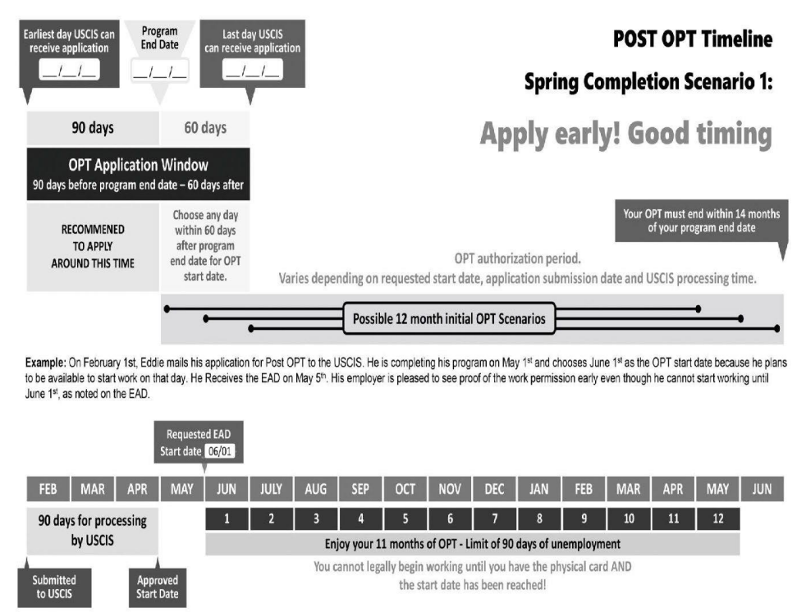 |  |  |  | 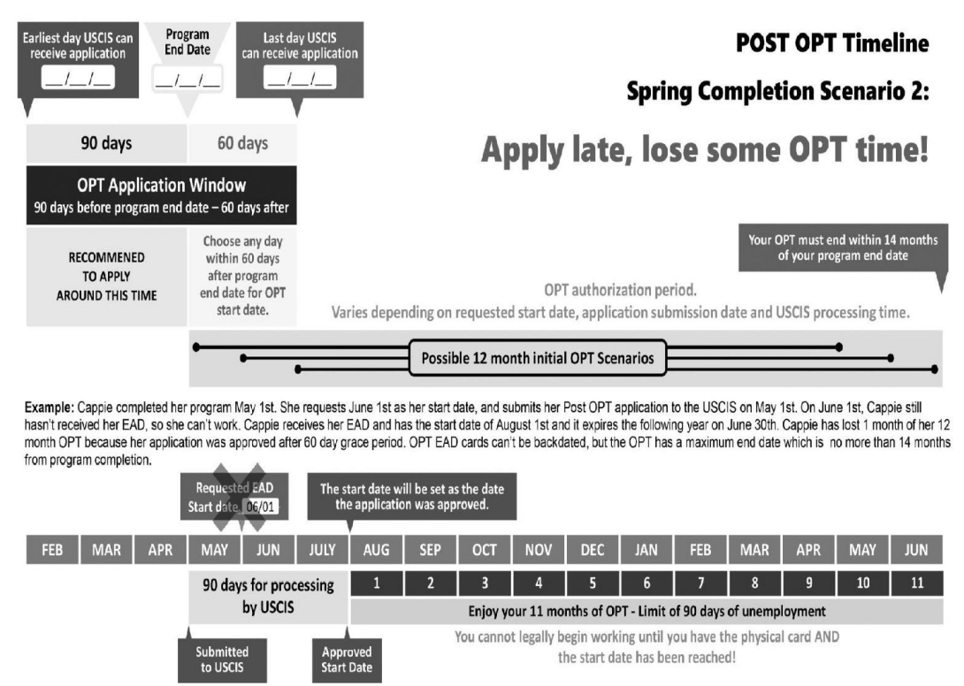

Appendices

What happens in the event the supervisory committee chair leaves the U of U?
For students that are going to graduate within a year of a faculty departure they can stay on as the main advisor without an appointment. This is only if a student will get done in a year. If it will take more than one year’s time from the faculty departure, the student should amend the supervisory committee.

*NEW* Parental Leave Policy for Graduate Students
As of 07/01/2022, the University has adopted a graduate student Parental leave policy benefiting all eligible University of Utah graduate students. The full Policy 6-409 Graduate Student Parental Leave can be found at https://regulations.utah.edu/academics/6-409.php.
Further Information from the Graduate School is Found Here.
Highlights of Graduate Student Parental Leave
- A Graduate Student is eligible for a Parental Leave of Absence if the Graduate Student has been matriculated in a Graduate Degree Program for at least one semester and is otherwise in Good Standing within their degree program at the time the Parental Leave of Absence is taken
- A Graduate Student who intends to take a Parental Leave of Absence shall notify the Graduate Student's advisor or program director at least 90-days before the anticipated birth or as soon as reasonably possible before adoption or foster placement for which the Graduate Student intends to take a Parental Leave of Absence. This allows the department and student to plan for the student's absence and ensure a seamless transfer of responsibilities.
- The Parental Leave of Absence is unpaid unless the Graduate Student is supported by a University Tuition Benefit Program eligible fellowship, teaching assistantship, graduate assistantship, or other research assistantship that the University administers.
- A Graduate Student eligible for paid Parental Leave of Absence may take a single Parental Leave of Absence for each birth, adoption, or foster placement and is eligible to take up to a maximum of two paid total Parental Leaves of Absence during the duration of their Graduate Degree Program. Alternatively, the eligible Graduate Student may choose to take a single unpaid Parental Leave of Absence for each birth, adoption, or foster placement, in lieu of, or in excess of, the above provided paid Parental Leaves of Absence. A Graduate Student not eligible for paid Parental Leave of Absence may take a single Parental Leave of Absence for each birth, adoption, or foster placement, without limits on the number of births, adoptions, or foster placements, during the duration of their Graduate Degree Program.
- An eligible Graduate Student may take a Parental Leave of Absence from a Graduate Degree Program for up to eight (8) consecutive weeks following a child's birth, adoption, or foster placement.
- The Graduate Student and the Graduate Student's advisor or program director shall discuss coursework completion, rearrangement of teaching and/or research duties, and timelines for academic matters that will be affected by the Parental Leave of Absence and create a jointly signed agreement that describes how the Graduate Student will complete these requirements following the Parental Leave of Absence. The Graduate Student shall submit the written agreement to the Graduate School as part of the Graduate Student's application for a Parental Leave of Absence.
- The Graduate School will forward any Graduate Student Parental Leave requests to HR Absence Management Team for FMLA consideration.

Time to Completion
Once admitted to the program, students must complete all degree requirements and have their degree post in the following time limits:
- Master’s degree must be completed and posted within four consecutive years from the time of admission.
- Ph.D. degree must be completed and posted within six consecutive years from the time of admission.
A student must complete within the allotted time period. If not, a petition must be submitted to the Dean of Graduate
School with a timeline and recommendation for continuation by the student, supervisory committee, and Department Chair. If a petition is declined, the student will be discontinued from the program. Students whose studies have been interrupted for long periods of time may petition for an extension of time and may be required to complete additional courses, examinations, or demonstrate they are current in their field.

International Students
International students are responsible for maintaining their international status from time of admission through graduation. International Student and Scholar Services should be consulted regularly through the student career.
Graduate School policy requires all graduate students who are non-native speakers of North American English to be cleared by the International Teaching Assistant (ITA) Program prior to employment as a Graduate Teaching Assistant (GTA). The department recommends all international students attend this training regardless of funding.
All graduate students are expected to have or develop a proficiency in both written and oral English. Any student lacking English proficiency as evidenced by speech, written reports, and/or oral presentations may be required to take additional English or speech coursework. Language courses do not count toward degree coursework requirements.

FERPA & Umail
The Family Educational Rights and Privacy Act (FERPA) requires faculty, staff, and graduate teaching assistants to only communicate about a student’s education history and plans with the student. If the student needs assistance from a family member, complete the FERPA release contract in the CIS system. Official university business is conducted through the Umail system and students need to use that email for all university correspondence.

Grades & Probation Policy
Candidates for all graduate degrees are required to maintain a 3.0 or higher GPA to graduate and make continuous forward progress towards their degree. Only one course (maximum of 4 credit hours) with a minimum grade of ‘C+’ or ‘C’ may be accepted for credit toward a graduate degree. Failure to do so will result in the student being placed on probation. Funded students with a GPA below 3.0 are ineligible to receive Tuition Benefit.
If a graduate student is on probation, the student must meet with the department academic advisor and submit a Probation Form signed by their Committee Chairperson. If a student is unable to bring up the GPA at the end of the second semester on probation, they may be terminated from the program.
Only research credits (CVEEN 6970 or CVEEN 7970) can be taken as Credit/No-Credit (CR/NC). If the student is not showing satisfactory progress for their research, a grade of No Credit (NC) will be given.

Registration
Graduate School requires graduate students to be registered from the time of admission through completion of all requirements for the degree they are seeking, unless granted an official Leave of Absence (domestic students only) or Vacation Semester (international students only). This policy does not include summer registration for domestic students. If a student does not comply with the university or department continuous enrollment policy, their record will be discontinued and will need to reapply for admission.
The department requires all Graduate Research Assistants (GRA) working 20 hours per week in summer semester to register for 3 credits of research (CVEEN 6970 or 7970) if they are tuition benefit eligible. Students must be registered the semester of any exams or defense.

Leave of Absence and Vacation Semesters
Domestic students who want to take a leave of absence for fall or spring semester must complete a Request for Leave of Absence form and have it approved by the faculty advisor two weeks prior to the start of the leave semester. Summer registration is not required unless a student is being paid as a Graduate Research Assistant (GRA) and tuition benefit eligible.
International students are required to continuously enroll full-time in fall, spring and summer. The International Student and Scholar Services should be consulted regarding a Vacation Semester and all INS regulations and questions.

Independent Study
A maximum of 3 credit hours of Independent Study (6930 or 7930) can be taken if approved by petition to the Graduate Committee. Independent Study credits should be overseen by a faculty other than the student’s supervisory committee chair and approved by petition prior to registering.

Academic Calendar
(Found at: https://registrar.utah.edu/academic-calendars/archive/index.php)
See on the following page.

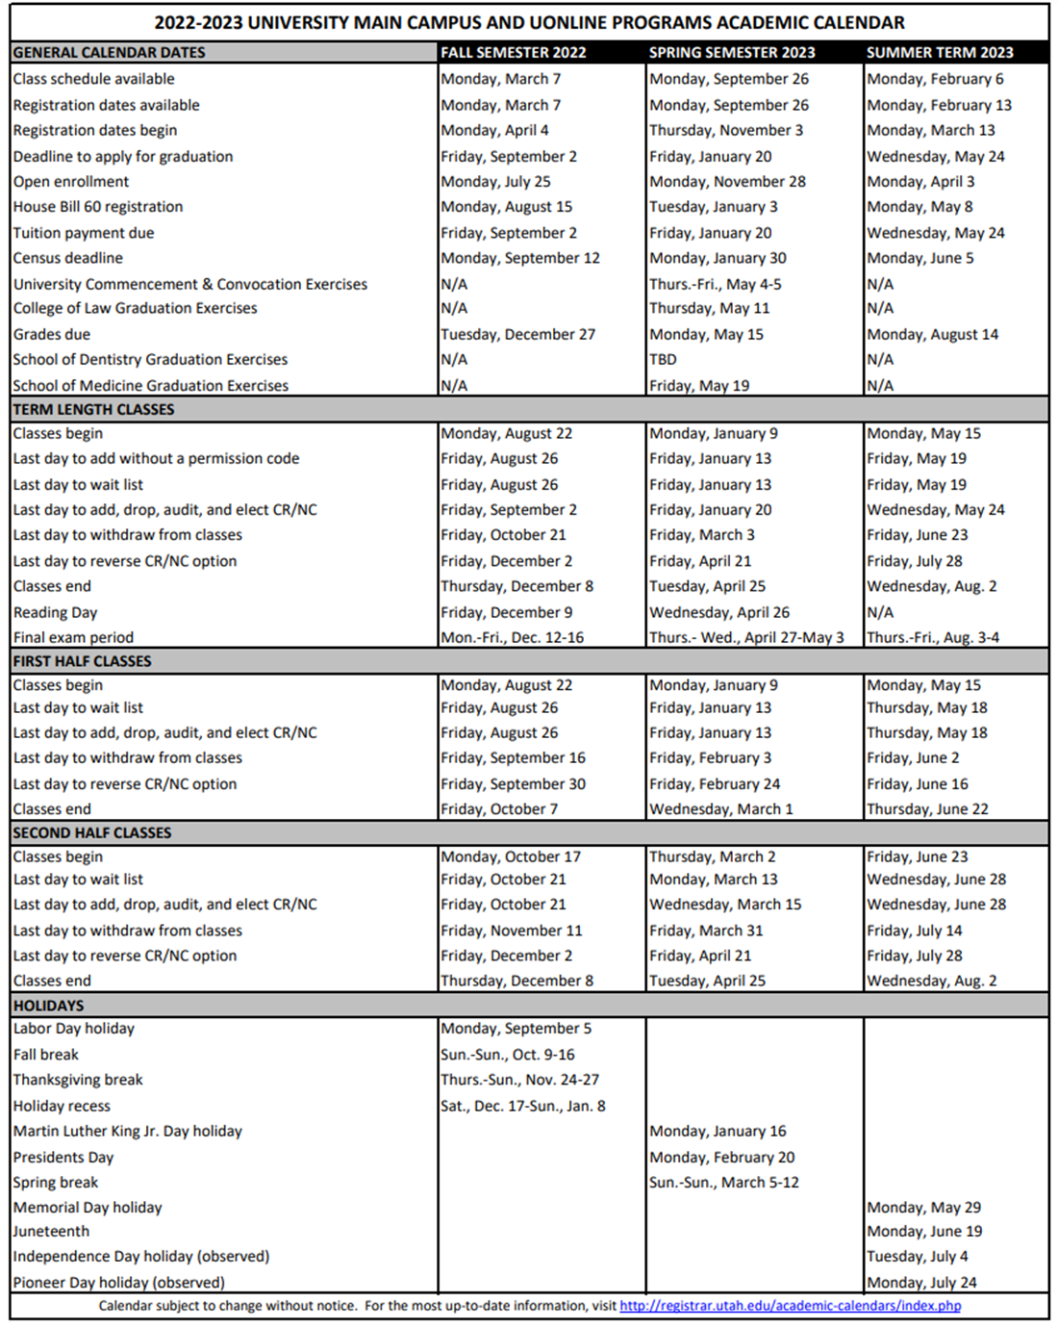

Coursework Requirements by Discipline

Water & Environmental
Core Courses |  | Even Spring |  | Even Fall | Odd Spring | Odd Fall
CVEEN 5410 | Engineering Hydrology |  |  | X |  | X
CVEEN 5420 | Open Channel Flow | X |  |  | X
CVEEN 6430 | Stormwater Management and Design |  |  |  |  | X
CVEEN 6440 | Water Distribution Systems Design |  |  |  | X
CVEEN 6470 | Surface Water Quality Prediction and Assessment |  |  | X
CVEEN 6480 | Water Resources Planning and Management |  |  |  | X
CVEEN 6600 | Hazardous and Radioactive Waste Management | X
CVEEN 6605 | Water and Wastewater Treatment Design |  |  | X |  | X
CVEEN 6610# | Environmental Engineering Chemistry |  |  | X |  | X
CVEEN 6620 | Environmental Processes | TBD
CVEEN 6650# | Design of Biological Treatment Processes |  |  | X
CVEEN 6555 | Engineering Research and Seminar |  |  | X |  | X
CVEEN 6775 | Environmental Regulations | TBD
CVEEN 6920 | Advanced Topics (in the area of water or environmental) * |  |  | X
CVEEN 6930 | Advanced Independent Study* | X |  | X | X | X
CVEEN 7410 | Flood Modeling and Simulation | X
CVEEN 7420 | Groundwater Hydraulics | (Coming soon)
CVEEN 7430 | Advanced Subsurface Hydrologic Modeling | X
CVEEN 7450 | Carbon Sequestration Engineering and Science | (Coming soon)
CVEEN 7460 | Hydroinformatics |  |  | X |  | X
CVEEN 7620 | Physical and Chem. Treatment Processes for Water Qual. Control | X
CVEEN 7630 | Field and Lab Methods for Environmental Practices | (Coming soon)
CVEEN 7660 | Water Reuse | X
Elective courses listed next page.
# Required of all students in the environmental area
*CVEEN 6920, special topics courses that are not in the Water/ Environmental area will need to be petitioned to the student's supervisory committee to be counted towards the required core courses.

Approved Elective Courses |  | Even Spring | Even Fall | Odd Spring | Odd Fall
ATMOS 6040 | Environmental Statistics |  |  | X
ATMOS 6050 | Environmental Instrumentation | X
CH EN 6205 | Smart Systems |  |  | X
CH EN 6305 | Air Pollution Control Engineering | X |  | X
CH EN 6310 | Concepts and Applications in Renewable Energy |  | X
CH EN 6355 | Computational Fluid Dynamics |  |  | X
ECON 6250 | Environmental and Natural Resource Economics |  |  |  | X
GEOG 5290 | Water in Utah
GEOG 6000 | Advanced Geographical Data Analysis |  | X |  | X
GEOG 6110 | Environmental Analysis Through Remote Sensing | X |  | X
GEOG 6150 | Spatial Database Design for GIS |  | X |  | X
GEOG 6180 | Geoprocessing with Python |  | X |  | X
GEO 6350 | Groundwater |  | X |  | X
GEO 6370 | Environmental Contaminants |  | X |  | X
GEO 6385 | Introduction to Groundwater Modeling | X |  | X
GEO 6390 | Solute Transport and Subsurface Remediation | X |  | X
GEO 6650 | Hydrology |  | X |  | X
LAW 7230 | Water Law |  |  |  | X
LAW 7240 | Environmental Law & Policy |  |  | X | X
ME EN 6740 | Wind Energy
ME EN 6750 | Environmental Instrumentation | X
ME EN 6800 | Sustainable Energy |  | X |  | X
ME EN 7710 | Environmental Fluid Dynamics
POLS 6870 | Environmental Justice
SOC6840 | Environmental Sociology | X
Any CVEEN 6xxx or 7xxx course approved by the student's supervisory committee.
Appropriate courses not listed may be approved for elective credit by the student' supervisory committee.
Please note, for CVEEN 6930: Independent Study, the proposal must be submitted to the Graduate Committee Four+ weeks prior to the start of the intended term of enrollment. The faculty responsible for overseeing the independent study may not be the student's committee chair.

Transportation & Materials
Core Courses
CVEEN 6510 | Highway Design
CVEEN 6530 | Quantitative Methods in Transportation Operation
CVEEN 6560* | Transportation Planning
CVEEN 6570 | Pavement Design
CVEEN 6920 | Optimization in Transportation
CVEEN 7545 | Transportation Infrastructure Maintenance
CVEEN 7550 | Advanced Construction Materials
CVEEN 7920 | Advanced Topics (In Transportation)
* Required of all transportation students.
Elective Courses
CS 6140 | Data Mining
GS 6350 | Machine Learning
GEOG 6160 | Spatial Modeling in GIS
GEOG 6180 | Geoprocessing with Python
Note: Any CVEEN 6xxx or 7xxx can be approved by the supervisory committee as electives. Additionally, relevant courses in other departments not listed here can be approved by the student’s supervisory committee for elective credit.

Structures & Geotechnical
Core Courses
As part of the 15 CORE Credits, structural and geotechnical students should take at least one course from each one of the following areas.
* Structures Area |  | * The requirement can be partially or fully waived if the student passed at least one of the courses (or equivalent) in undergraduate studies. The waiver will not reduce the minimum credit course requirements for the MS degree.
CVEEN 6210 | Structural Analysis II
CVEEN 6220 | Concrete Design II
CVEEN 6230 | Steel Design II
CVEEN 6250 | Structural Dynamics
* Geotechnical Area
CVEEN 5305 | Intro. to Foundation Eng.
CVEEN 6310 | Foundation Engineering
CVEEN 6330 | Soil Dynamics
CVEEN 6350 | Soil Improvement and Stabilization
CVEEN 6920 | Numerical Methods in Geotech. Eng.
CVEEN 5305 | Intro to Foundation Eng.
CVEEN 6210 | Structural Analysis II
CVEEN 6220 | Concrete Design II
CVEEN 6225 | Concrete Science
CVEEN 6230 | Steel Design II
CVEEN 6240 | Masonry/ Timber Design
CVEEN 6250 | Structural Dynamics
CVEEN 6270 | Computer- Aided Structural Analysis
CVEEN 6310 | Foundation Engineering
CVEEN 6330 | Soil Dynamics
CVEEN 6340 | Advanced Geotechnical Testing
CVEEN 6350 | Soil Improvement and Stabilization
CVEEN 6510 | Highway Design
CVEEN6525 | Highway and Traffic Engineering
CVEEN 6570 | Pavement Design
CVEEN 6790 | Advanced Computer Aided Construction
CVEEN 7225 | Prestressed Concrete Design
CVEEN 7230 | Topics in Steel Design
CVEEN 7235 | Bridge Design
CVEEN 7250 | Structural Earthquake Engineering
CVEEN 7255 | Advanced Dynamics of Structures
CVEEN 7310 | Advanced Foundation Engineering
CVEEN 7330 | Geotechnical Earthquake Engineering
CVEEN 7360 | Advanced Soil Mechanics
CVEEN 7450 | Carbon Capture and Store Transportation
CVEEN 7520 | Safety
CVEEN 7560 | Advanced Materials
CVEEN 7570 | Pavement Maintenance and Rehabilitation

Structures & Geotechnical (Continued).
Elective Courses
Only 9 credits outside of the Department may be used towards a master’s degree. Other courses may be approved by Supervisory Committee.
CVEEN 5305 | Intro. to Foundation Engineering | ME EN 6300 | Advanced Strengths of Materials
CVEEN 6225 | Concrete Material Science | ME EN 6400 | Vibrations
CVEEN 6235 | Bridge Design | ME EN 6510 | Introduction to Finite Elements
CVEEN 6260 | Applied Probability and Statistics | ME EN 6520 | Mechanics of Composite Materials
CVEEN 6350 | Soil Improvement and Stabilization | ME EN 7060 | Fatigue and Creep Considerations in Design
CVEEN 6710 | Cost Estimating and Proposal Writing | ME EN 7070 | Tribology and Corrosion Considerations in Design
CVEEN 6720 | Project Scheduling | ME EN 7530 | Fundamentals of Fracture Mechanics
CVEEN 6730 | Project Mgmt and Contract Admin. | ME EN 7540 | Advanced Finite Elements
CVEEN 6750 | Engineering Law and Contracts | ME EN 7550 | Theory of Plates and Shells
CVEEN 6920 | Special Topics (in Materials, Structures, Geotechnics only) | MET E 6100 | Micromechanisms of Fatigue and Fracture
CVEEN 6930 | Independent Study | MET E 6250 | Fundamentals of Engineering Analysis
CVEEN 6xxx | Infrastructure Sensing & Health Monitor | MET E 6300 | Alloy and Material Design
CVEEN 7260 | Seismic Rehab of Reinforced Concrete Bldg. | MET E 6450 | Mechanical Metallurgy
CVEEN 7920 | Special Topics (in Materials, Structures, Adv. Materials Testing Geotechnics only) | MET E 6600 | Corrosion Fundamentals & Minimization
CVEEN 7930 | Adv. Independent Study | MG EN 5150 | Mechanics of Materials
CS 5600 | Intro. to Computer Graphics | MG EN 5270 | Landslides and Slope Stability
CS 6300 | Artificial Intelligence | MG EN 5290 | Introduction to Finite Element Modeling in Geomechanics
CS 6610 | Interactive Computer Graphics | MSE 5032 | Thermodynamics of Solids
GEO 5075 | Intro. to Geological Engineering | MSE 5475 | Introduction to Composites
GEO 5150 | Geological Engineering Design | MSE 6001 | Engineering Materials
GEO 5200 | Depositional Environments
GEO 5210 | Seismology I: Tectonophysics and Elastic Waves
GEO 5220 | Seismology II: Exploration and Engineering Seismology
GEO 5320 | Signal and Image Processing in the Geosciences
GEO 6160 | Clay Mineral Geochemistry
GEO 6260 | Petrophysics and Well-Logging
GEO 6330 | Earthquake Seismology and Risk Assessment
GEO 6350 | Groundwater
GEO 6360 | Fluid Dynamics of Earth Materials
GEO 6370 | Contaminant Partitional for Engineering and Scientists
GEO 6660 | Geochemistry
MATH 6420 | Partial Differential Equations
MATH 6610 | Analysis of Numerical Methods I
MATH 6620 | Analysis of Numerical Methods II

Nuclear
Master’s-Level Requirements:
- Graduate credit hours are listed as 5000 and above.
- Students can include no more than 9 credit hours of graduate level non-matriculated coursework, taken within 3 years of credit hour approval, with a final grade of B or better.
- Students can apply no more than 6 credit hours of graduate level coursework from another institution, with a final grade of B or better. This credit may not have counted towards the completion of a prior degree.
- Up to 3 credits of independent research, taken as NUCL 6900 or 7900.
- Up to 12 credits of electives offered by other departments in engineering, science, and math-related disciplines that complement the student’s research. Elective courses may be taken in any science, engineering, technology discipline that supports your research.

MS students must complete a minimum of 30 hours of graduate level coursework.
Required Courses. | Choose a minimum of FOUR additional electives from the list below.
NUCL 6030: Graduate Radiation Interactions (3 cr.)  NUCL 6050: Reactor Physics (3 cr.) | NUCL 5060: Reactor Operation and Regulatory Policy (3 cr.)  NUCL 6032: Graduate Radiochemistry (3 cr.)  NUCL 7110: Nuclear Environmental Engineering (3 cr.)  NUCL 7220: Analytical Nuclear Forensics (3 cr.)  NUCL 7000: Health Physics (3 cr.)  NUCL 7500: Nuclear Safeguards (3 cr.)  NUCL 7100: Nuclear Instrumentation (4 cr.)  MET E 6210: Nuclear Materials (3 cr.)  CVEEN 6120: Numerical Methods (3 cr.)

Doctoral – Level Requirements:
- Graduate credit hours are listed as 5000 and above.
- Students can include no more than 9 credit hours of graduate level non-matriculated coursework, taken within 3 years of credit hour approval, with a final grade of B or better.
- Students can apply no more than 6 credit hours of graduate level coursework from another institution, with a final grade of B or better. This credit may not have counted towards the completion of a prior degree.
- Up to 3 credits of independent research, taken as NUCL 6900 or 7900.
- Up to 12 credits of electives offered by other departments in engineering, science, and math-related disciplines that complement the student’s research. Elective courses may be taken in any science, engineering, technology discipline that supports your research.

Required Courses. (These NUCL courses serve as the basis of the qualifying exam.)
- CVEEN 6555: Research and Seminar (3 cr.) – All students starting Fall 2020 and after.
- NUCL 6030: Graduate Radiation Interactions (3 cr.)
- NUCL 6050: Reactor Physics (3 cr.)
- NUCL 7000: Health Physics (3 cr.)
- NUCL 7100: Nuclear Instrumentation (4 cr.)

Choose a minimum of two additional NUCL electives from the list below.
- NUCL 6032: Graduate Radiochemistry (3 cr.)
- NUCL 6060: Reactor Operation and Regulatory Policy (3 cr.)
- NUCL 7110: Nuclear Environmental Engineering (3 cr.)
- NUCL 7220: Analytical Nuclear Forensics (3 cr.)
- NUCL 7500: Nuclear Safeguards (3 cr.)
- MET E 6210: Nuclear Materials (3 cr.)
- CVEEN 6120: Numerical Methods (3 cr.)
Credit Hour Requirements
 | Coursework | Research
MS to PhD | Minimum of 18 credits | Minimum of 14 credits
Direct Admit (no MS) | Minimum of 30 credits | Minimum of 14 credits

A directory of Resources:
Getting to Campus

UTA Transit Pass | commuterservices.utah.edu/mass-transit/
Parking Services | commuterservices.utah.edu/campus-parking
New to the U Resources

Campus Map | map.utah.edu
University ID Card (UCard) | ucard.utah.edu
New Student Guide from University Information Technology (UIT) | Includes: Free/ discounted software, connecting to the university’s wireless network, security policies
Mobile U | Download App Here. Features include: (1) Shuttle tracker, (2) Arts Pass, (3) Scholarships and financial aid, (4) Health and wellness resources
Check-Out Equipment  (Laptop, iPad, Camera) | Marriott Library, Knowledge Commons
Connecting to WIFI | Instructions here.
Grammarly | gradschool.utah.edu/grammarly
ZoomPro Account | utah.zoom.us
Campus Safety

Campus Alert System | alert.utah.edu
Department of Public Safety | dps.utah.edu
Conflict Resolution

Dean of Students | deanofstudents.utah.edu
Faculty Ombudsman | academic-affairs.utah.edu/office-for-faculty/facultyombudsman

Health Care Resources

Student Health Center | studenthealth.utah.edu
Center for Student Wellness | wellness.utah.edu
University Counseling Center | counselingcenter.utah.edu
Subsidized Health Insurance | gradschool.utah.edu/tbp/insurance-information/
Financial Resources
Direct Deposit Information |  | https://www.hr.utah.edu/payroll/paycheck.php)
Pay Period Calendar

Subsidized Health Insurance |  | gradschool.utah.edu/tbp/insurance-information
Residency for Tuition Purposes |  | admissions.utah.edu/apply/residency
Tuition Benefit Program |  | utah.edu/tbp/tuition-benefit-program-guidelines
Personal Money Mgmt Center |  | asuupmmc.utah.edu
Resources Specific to Graduate Students
Graduate School |  | gradschool.utah.edu
Marriot Library Graduate Resources |  | lib.utah.edu/services/education/gradstudents
Writing Center |  | writingcenter.utah.edu/Gradstudentservices.php
Additional Resources
LBGT Resource Center | Including a map of gender-free restrooms  lgbt.utah.edu
Center for Disability Access | disability.utah.edu
Office of Equal Opportunity, Affirmative Action and Title IX | oeo.utah.edu
Women’s Resource Center | womenscenter.utah.edu
Veterans Support Center | veteranscenter.utah.edu
International Student Services | internationalcenter.utah.edu
Childcare Resources | childcare.utah.edu

